PROJECT:SANDSTONE

ORGANISATION:SANDSTONE

INTRODUCTION

SANDSTONE is a national high-tech enterprise that provides big data smart storage products and solutions in the era of 5G + AIoT.  Since its establishment in 2014, the company, with the new  generation of intelligent distributed storage technology as the  core, is committed to building the cornerstone of data storage  in cloud computing, artificial intelligence, Internet of Things and  other fields.

The company, headquartered in Shenzhen, has 16 offices and  a nationwide service network. Its products have realized large scale commercial deployment in more than ten industries,  supporting more than 20 different types of application  scenarios such as private cloud, hybrid cloud, finance  technology, smart government, smart medical care, smart  transportation and smart security.

As the leader of the new generation of intelligent storage  products and solutions based on big data, SANDSTONE has  accumulated more than 60 invention patents and software  copyrights, and is a member of Cloud Computing Standards  Working Group of National Information Technology  Standardization Network.

**Project Summary :**

|  |  |
| --- | --- |
| **Website** | **http://www.szsandstone.co/** |
| **organisation/foundation name** | **Sandstone** |
| **License** | **Not open source** |
| **Open proprietary** | **Not open source** |
| **Source path(if open source)** |  |
| **Brief description** | **SandStone is committed to provide leading enterprise storage solutions for different business use**  **case, help customer easily cope with the storage challenges of cloud migration, and provide intelligent storage for business decisions in the era of big data.**  **The flexibility and flatness of object storage make it possible to store a large amount of data by means of expansion** |

**PROJECT DETAILS**

**KEY FEATURES:**

* **Rapidly changing infrastructure**

**It is rapidly changing infrastructure and realize the high scalability and flexibility of IT system**

* **SandStone UPS**

**It is a brand-new software-defined storage system can provide block and file storage services**

* Provide block and file interfaces to meet the requirements of critical business for flexible and SandStone efficient storage
* USP organizes the hard disks and SSD in commercial servers into EB-level large-scale storage resource pools through distributed technology to provide standard service interfaces for enterprise applications

ARCHITECTURE

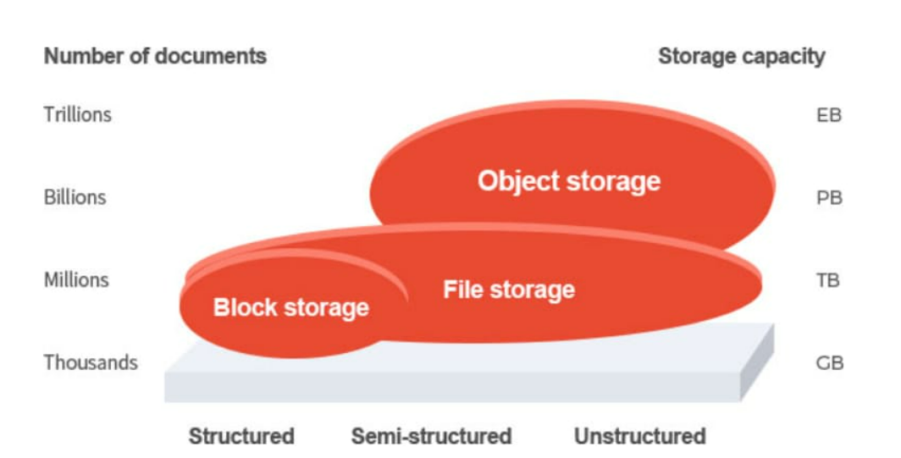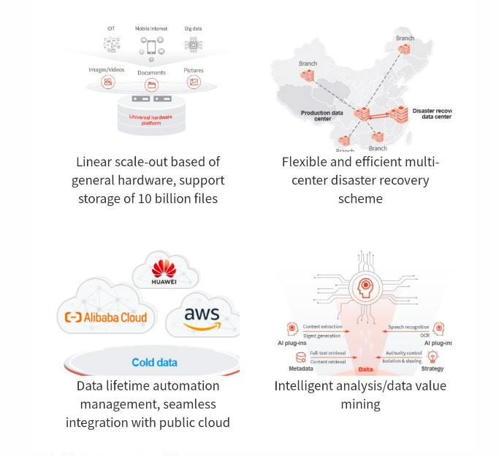

CURRENT USAGE:

Currently, enterprise applications obviously tend to be mobile and intelligent and the types of the data generated by applications are changing, with pictures, videos, voice, documents and other unstructured data absolutely dominant in the total enterprise data. Moreover, traditional storage has become a bottleneck in the digital transformation of enterprises and it is a must to choose more appropriate storage technology for IT infrastructure construction.

At present, more than**80%**of new data are unstructured data;

More than**95%**data is unstructured data in the future.

* ENTERPRISE CONTENT MANAGEMENT
* AI APPLICATIONS
* IMAGE/VIDEO STORAGE
* BROADCASTING MEDIA
* BIG DATA STORAGE AND ANALYSIS
* BACKUP/ARCHIVING

TECHNICAL DETAILS

In order to respond quickly to the requirements of the rapidly changing infrastructure and realize the high scalability and flexibility of IT system, virtualization, private cloud and container technology are widely used in IT infrastructure, and the enterprise data center architecture is becoming increasingly complex, so the traditional SAN + NAS storage scheme can not meet the complex application requirements any moreh

SandStone USP as a brand-new software-defined storage system can provide block and file storage services, support various database workloads, virtualization applications and cloud native applications at the same time, and meet the requirements of key businesses and various applications for storage. So far, bimodal IT has become the new normal of enterprise IT; the elastic software-defined architecture enables SandStone USP not only support a wide range of multi-virtualized scenarios, but also integrated well with the ecosystem of mainstream container platforms, so it can provide applications with high-performance snapshot, cross-data-center disaster recovery and other enterprise-level storage services. Moreover, its software system can be deployed in a general server, able to constantly update the hardware so that the system could always be kept in the best state and could quickly respond to the requirements of complex and dynamic business in the future.

PARTNERS:

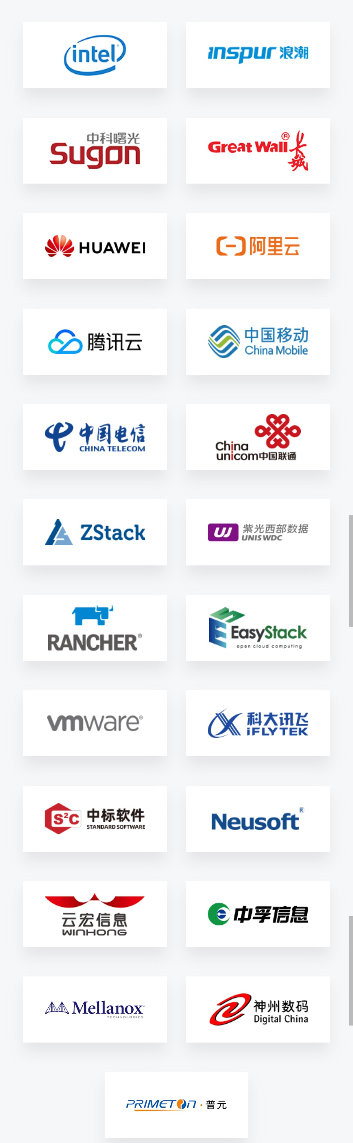

c

business data, such as Cloudera big data platform, telecom operator log analysis, financial fraud detection and gene data sequencing.

Spark and other big data analysis platforms and provide

* complete solutions for collection, storage and analysis of different business data, such as Cloudera big data platform, telecom operator log analysis, financial fraud detection and gene data sequencing.